Maddison Verdone
SED 5140- Kaseta
Behavior Plan Project
Student Information - *names have been changed to protect identity and confidentiality*
For this project, I chose to work with a 4th grade student, Corey, that I have observed in multiple classrooms this year. I work closely with his teacher for another student in his classroom, and have heard a lot about Corey. Corey is a new student to the school and district this year. He transferred to this school because, according to his aunt, his mom cannot take care of him anymore and he had to move in with the aunt. He has had multiple referrals thus far, and has been suspended twice. He does not have an IEP or a 504 plan. He is involved in the mentoring groups that the school provides for the young boys. Each boy is paired up with one of the male staff members and they do character building activities. I selected Corey for many reasons. Corey is getting good grades in all of his subjects. His teachers describe him as “extremely smart,” and “beyond 4th grade level.” His disruptive behavior is what is holding him back from being an all around stellar student. His teacher has been having a very hard time figuring out how to address the disruption, while not distracting all of the other students away from the lesson.
Target Behavior
The target behavior I am focusing on for this project with Corey is shouting out in class without raising his hand for permission to speak, and talking at inappropriate times. This behavior passes the stranger test, because anyone who walks in the room for more than 10 minutes during a lesson will see Corey shout out at least once. This behavior passes the so-what test, because Corey’s outbursts disrupt the teachers lesson, as well as student learning when he is talking at inappropriate times. Multiple students have asked not to sit at Corey’s table because he is distracting when he shouts out answers and his thoughts. This behavior undeniably passes the dead man’s test because a dead man cannot speak or shout out without permission. The target behavior is a fair pair because, the goal of the intervention is to increase Corey talking at appropriate times and raising his hand to share his thoughts, while decreasing his blurting out without asking permission or at inappropriate times.
Recording Technique
For this situation, I chose to use a frequency recording form. I chose this because, according to the text, “It is the most commonly used technique, as well as the most advantageous, because it is fairly easy to do, produces a number that can be graphed, and applies to many disruptive behaviors in the classroom…” (5-4a) This recording method was very easy to use, and could be done very quickly. I used a post-it note kept on my clipboard that I always have with me to record on. I split the post-it into 7 sections, one for each hour of the school day. Within each hour’s spot, I tallied how often I saw the behaviors. This drew the least amount of attention to my recording, and took the least amount of time.
Intervention
The intervention I selected was a token economy. I used a punch card reward system for this student. There are 20 punch holes on the card, and each time Corey raised his hand rather than speaking out of turn, he received a hole punch. I chose this intervention strategy for multiple reasons. The first reason is that in my experience, this strategy is the most effective for almost all students. I have heard of so many teachers who have used this strategy and saw great results with their students. My next reason for using the token economy is that it is easy to implement and does not take time away from teaching the whole group. I introduced this by having a conversation with Corey about the target behavior and what he can do instead of that behavior in order to earn a hole punch. Together, we then created a menu of rewards with him. Corey chose the following options for his possible rewards: lunch with me, computer time, game time, snack of his choice, DoJo points, or a pick from the prize box. Once he earned all 20 hole punches, I had him write his reward choice on the back of the card and turn it into my classroom mailbox. I also chose a token economy because the text says that they are more likely to “maintain a student’s behavior over long periods of time” (9-2). Because Corey’s behaviors are so disruptive to his classroom, I wanted to try something that would be more lasting once I was no longer working with him. I also wanted what I did to be something easy for his regular teacher to pick up and continue with.
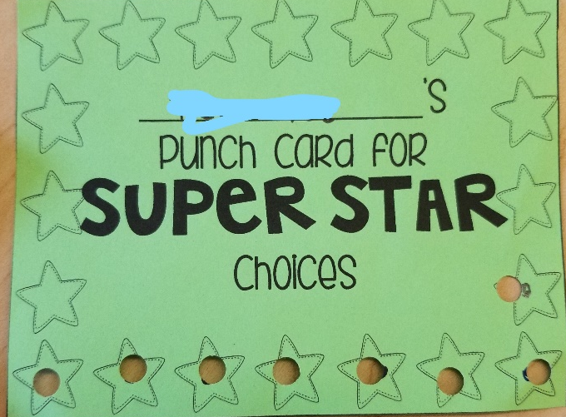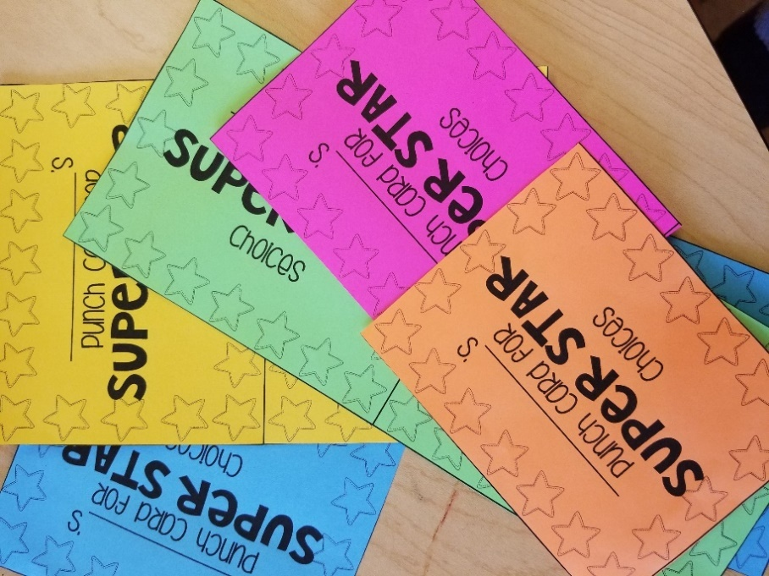

Frequency Recording Sheets
Student: Corey Date: 8 days between 9/8/17-12/1/17
Observer: Mrs. Verdone Time Began: 8:15
Time Ended: _3:15
Target Behavior: talking or shouting out at inappropriate times/without permission.
Date | Time  Start Stop | Notations of  Occurrences | Total Occurrences in  1 day
9/8/17 (baseline) | 8:15 a.m. – 3:15 p.m. | 8-9 a.m.: 4  9-10 a.m.: 3  10-11 a.m.: 4  11-12 p.m.: 2  12-1 p.m.: 3  1-2 p.m.: 4  2-3 p.m.: 4 | 24
9/22/17 (baseline) | 8:15 a.m. – 3:15 p.m. | 8-9 a.m.: 3  9-10 a.m.: 4  10-11 a.m.: 4  11-12 p.m.: 1  12-1 p.m.: 3  1-2 p.m.: 3  2-3 p.m.: 3 | 21
10/13/17 (baseline) | 8:15 a.m. – 3:15 p.m. | 8-9 a.m.: 2  9-10 a.m.: 3  10-11 a.m.: 4  11-12 p.m.: 2  12-1 p.m.: 4  1-2 p.m.: 4  2-3 p.m.: 3 | 22
10/27/17 (baseline) | 8:15 a.m. – 3:15 p.m. | 8-9 a.m.: 3  9-10 a.m.: 3  10-11 a.m.: 3  11-12 p.m.: 1  12-1 p.m.: 2  1-2 p.m.: 3  2-3 p.m.: 4 | 19
11/3/17 (intervention) | 8:15 a.m. – 3:15 p.m. | 8-9 a.m.: 2  9-10 a.m.: 2  10-11 a.m.: 1  11-12 p.m.: 1  12-1 p.m.: 2  1-2 p.m.: 2  2-3 p.m.: 1 | 11
11/10/17 (intervention) | 8:15 a.m. – 3:15 p.m. | 8-9 a.m.: 2  9-10 a.m.: 2  10-11 a.m.: 1  11-12 p.m.: 1  12-1 p.m.: 1  1-2 p.m.: 2  2-3 p.m.: 2 | 11
11/17/17 (intervention) | 8:15 a.m. – 3:15 p.m. | 8-9 a.m.: 2  9-10 a.m.: 1  10-11 a.m.: 1  11-12 p.m.: 0  12-1 p.m.: 1  1-2 p.m.: 2  2-3 p.m.: 1 | 8
12/1/17 (intervention) | 8:15 a.m. – 3:15 p.m. | 8-9 a.m.: 1  9-10 a.m.: 1  10-11 a.m.: 0  11-12 p.m.: 0  12-1 p.m.: 1  1-2 p.m.: 2  2-3 p.m.: 1 | 6

Graphs (first two pictures are baseline data, the third and fourth pictures are intervention data)
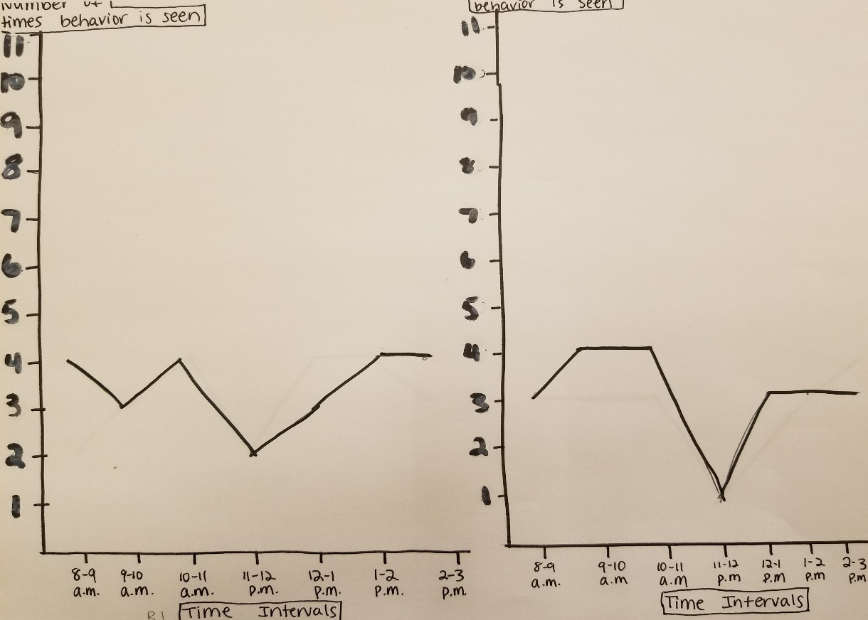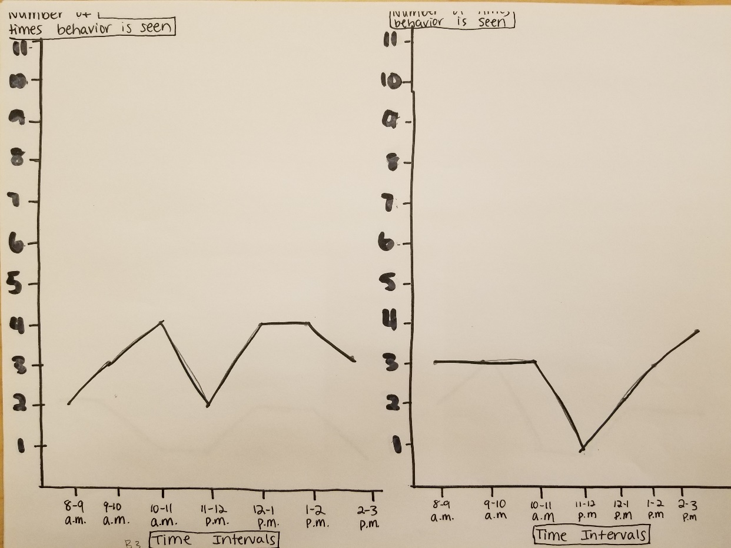
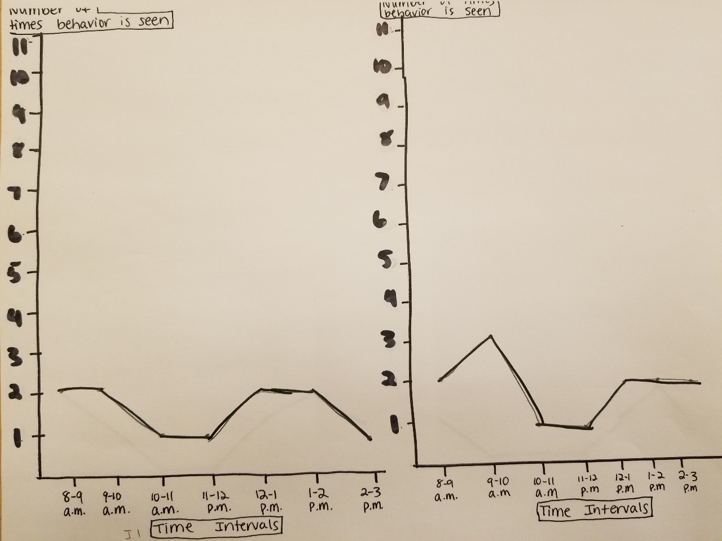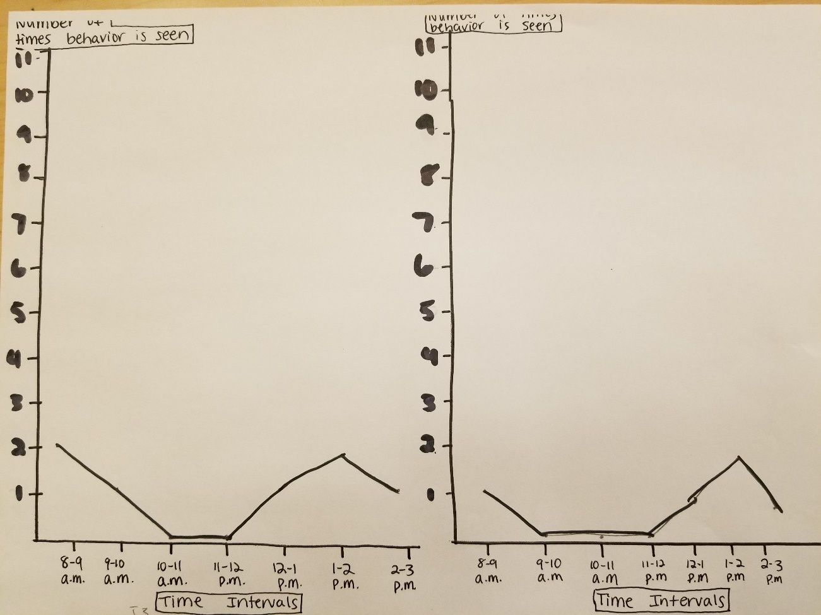
Conclusion
The first time Corey earned a reward, he was so proud of himself. He chose lunch with me for his first reward. During our lunch time, we had a conversation about how good it felt to be earning his hole punches and a reward. He told me that he lost his iPad at home because of how much trouble he was getting into at school. He said, “I used to get in trouble all the time, and then I would go home and my mom would be so mad. Now I have my iPad again.” Corey’s teacher has said that she plans on continuing to use this strategy with him after I leave. She has also said she is thinking about doing this with a few other students in her classroom that she believes may benefit from it. If I were to continue working with Corey, I would want to move away from extrinsically motivating strategies and work on creating and maintaining an intrinsic motivation to not perform the target behavior.
I learned a great deal while completing this project. I have seen, and heard of, many teachers implementing this kind of behavior intervention. This was the first time where I was able to introduce the strategy to the student and be the one responsible for following through with the hole punches and rewards. Managing difficult behaviors can be very challenging, especially for us novice teachers. This project makes me feel much more confident in my abilities to handle the challenging behaviors I will certainly be faced with in my career. I feel very confident that, in my future classrooms, I would be able to implement this behavior management strategy to better support my student’s success in my classroom.

Check Sheet
This checklist will make sure you have included the necessary information in your behavior management project.

Information Student’s Initials

1. Paper is double-spaced in 12 pt. font M.V

2. Pages numbered (typed) in upper right corners M.V

2. No covers or bindings M.V

3. Staple in upper left-hand corner n/a

4. Headings are used for each section M.V

5. Student description is one paragraph M.V

6. Target behavior section begins with M.V
definition of the target behavior

7. Target behavior section includes statements M.V
about how it passes the stranger test, so what
test, and dead man’s test, and is a fair pair

8. Recording sheets are included M.V

9. Intervention selected was one described M.V
in class and in textbook

10. Intervention section begins with the sentence M.V
“The intervention I selected was…”

11. Intervention includes all information described M.V
on page 3 of this document

12. Intervention materials are included M.V

13. Description of how reinforcers were M.V
determined is included

14. Provided graph was used M.V

15. Conclusion is two paragraphs M.V

Scoring Sheet
Stranger Test (5 points) points

The target behavior(s) should be operationally
defined. Behaviors that were recorded using
either frequency, duration, or latency recording
techniques should include a movement cycle.

Tests (5 points) points

You should describe how your target
behavior passed the stranger test,
so what test, and dead man’s test
and is a fair pair.

Recording Sheets (10 points) points

All recording sheets should be attached and tallied
correctly (e.g., interval or time-sample recording
sheets should include the percentage of
intervals the student engaged in the target
behavior(s)). You should include a rationale for using
the recording technique you selected.

Intervention Description (20 points) points

A description of the intervention should include
the procedures, steps, and copies of all sample
materials.

Accurately Graphing Behavior (5 points) points

All parts of the graph should be correctly marked.
You should refer to Section 6-2 and
Figure 6.2 to ensure that your graph is marked
correctly.

Check Sheet (5 points) points
All information from the check sheet
is included in the final project.

_____________________________

Total Points Earned points

