Inclusive teaching guide
By: Maddison Babcock
November 2016
SED 5600
Dr. Marshall-Reed

Table of Contents

Introduction…………………………………………………………………………. …..…… 2

Partnering with families………………………………………………….………....……….... 3

Inclusive teaching in the classroom:
- Classroom design and assistive technology……………………………………………....…… 5
- Building community & responding to behavioral challenges……………...…………………. 7
- Inclusive academic instruction ……………………………………………….………….…… 8
- Lesson plan examples………………………………………………………………….….…. 12

Support and collaboration …………………………………………………………………… 19

Strategies for change………………………………………………………………………… 20

References…………………………………………………………………………………… 21

Introduction
The purpose of this inclusive teaching guide is to present my knowledge and opinions on what I believe an exemplar inclusive classroom looks and feels like. This is not to say that this is practical in every school and school district given things like funding and class size. However, in my teaching practice, I strive to create an inclusive classroom environment as close to this as possible. I will make sure that all students in my classroom know that they matter. Each student is unique, has differing background knowledge, and learns in their own way. My job as an educator is to make necessary adjustments and adaptations to ensure the academic success of all learners in my classroom. My inclusive teaching guide is focused on a 2nd or 3rd grade inclusive classroom. I developed this guide by deeply reflecting on and synthesizing all of my knowledge gained in my coursework and experiences working in classrooms.
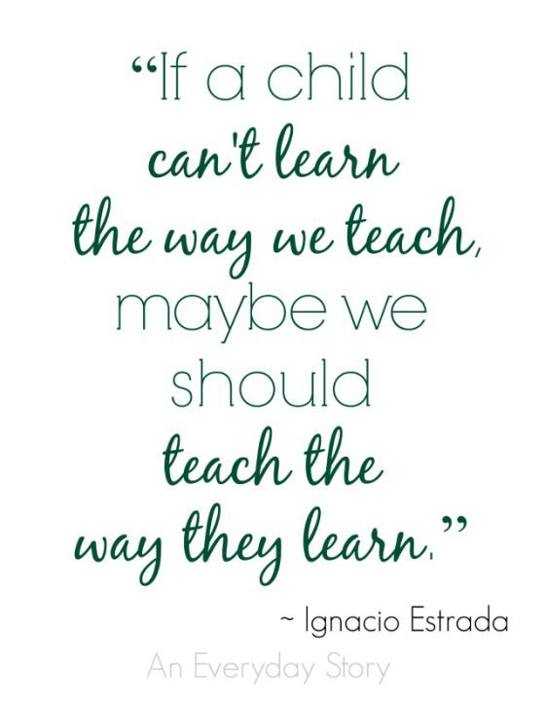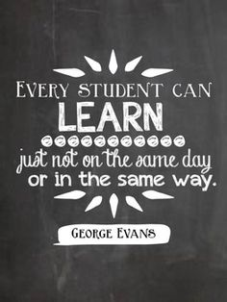
Partnering with Parents

I believe strong, positive, and meaningful relationships with families is the key to a successful school year, for all parties involved. I plan to work as a collaborative team with my student’s families to encourage and support both my student’s academic success, and their overall wellbeing.
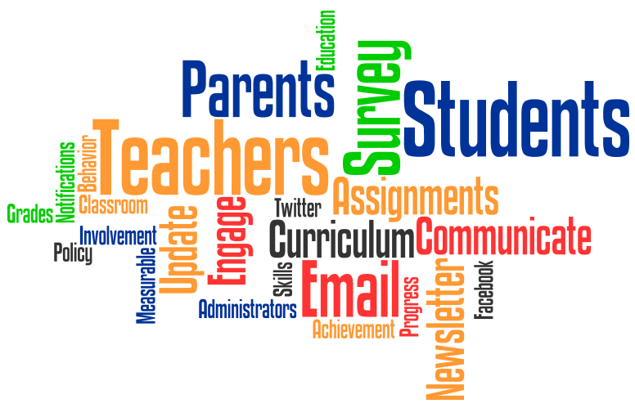
“Extensive research shows that family involvement can enhance a student’s chances for success in school and significantly improve achievement. Students have higher attendance rates, more pro-social behavior, better test scores, and higher homework completion rates when their families are engaged in home partnerships with schools” (Dettmer, Knackendoffel & Thurston, 2013).
Too often, parents are only communicated with if there are negative things to report about their child. I will ensure effective two-way communication. My first step, is to establish positive relationships by hosting a meet and greet night prior to the start of the year. At this time, I will try and meet with as many parents as possible to tell them about myself, give them my cell phone number, and make sure they know my classroom has an open door policy. I will make sure they know that I am always available to answer questions or clear up any confusions. I will make sure I am available at all times via cell phone or email. I will also give them a parent questionnaire for their involvement which is similar to a needs assessment, but will also have space for them to tell me their questions, thoughts, and concerns. Just as though I will ensure my students know they matter in my classroom, the parents and families of my students must know they matter just as much.
Effective two-way communication is the heart of successful school-home relationships. Parents and families should not only be passive recipients of information: they should be active participants in the partnership with the school. This is not easy and will not be possible with every family but when the effort is made on the school’s end, parents and families are much more likely to be involved. Parents must be addressed with respect and as equals. Inappropriate verbal and nonverbal language can severely hinder home-school partnerships. I will have a classroom website that has information about what is going on in the classroom, highlights students work, and reminders for upcoming events. I will send home weekly newsletters with the same information in the native language of the parents of my students who do not speak or read English. Each week I will send home a parent worksheet asking for questions, comments or concerns to be brought back so I may address these on an individual basis. I also will use the Remind communication tool to send parents positive notes about their students and reminders about homework and classroom events.

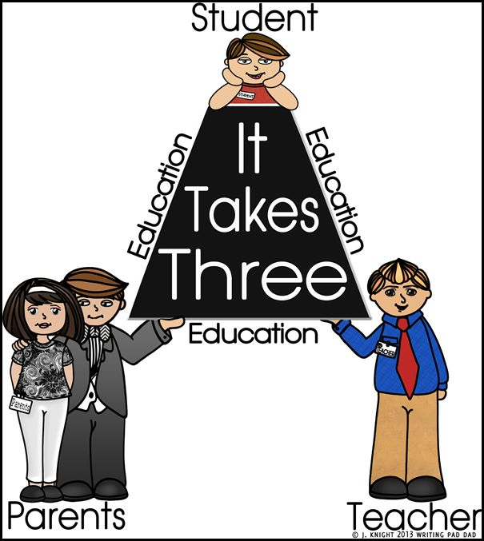

Classroom Design and Assistive Technology
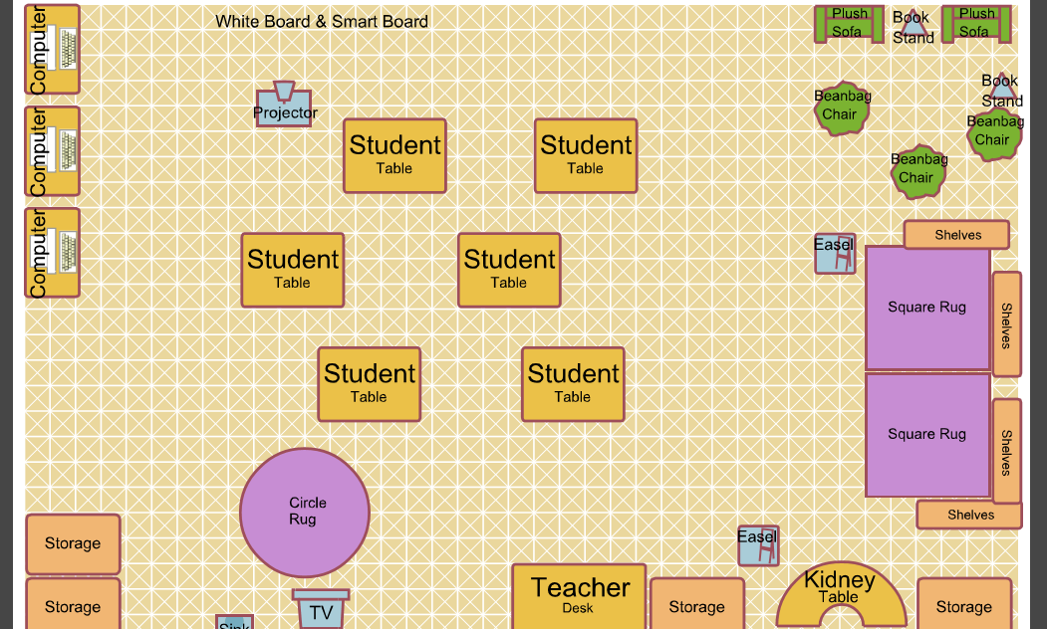
Designed on Classroom Architect (http://classroom.4teachers.org/)
When designing the layout of the classroom, it is crucial to understand the needs of my students, both physically and emotionally. The design of the classroom will impact how my students learn, interact, and behave. It will also address the varying learning styles of my students. The above picture shows my ideal 2nd or 3rd grade classroom. If I have any students who use a wheelchair, they can easily access all parts of the classroom. Every student in my classroom will know and feel that they are a vital part of our classroom community. I will have tables with computers so students can use them for various lessons. Students will be at tables in groups of 4. Each table will have students at varying ability levels so they can learn and grow from each other. I will have a kidney table set up for guided reading and guided math work times. The circle rug will be used for read aloud and morning meeting times. The square rugs will be surrounded by book shelves so students may read silently or to a friend there during centers. The sofas and beanbag chair will be set up for students to work independently on clip boards. This area will also be used if students need to take a break from the class for a few minutes. I will have student work hung outside the classroom as well as throughout the classroom. I am proud of my student’s accomplishments, and I want them to feel the same way. Easels will be set up at different locations in the classroom so anchor charts can be created as a class. A white board and smart board will be used for lessons so all students can see what is necessary. Using these boards will help students with visual impairments who may have difficulty seeing things on paper.
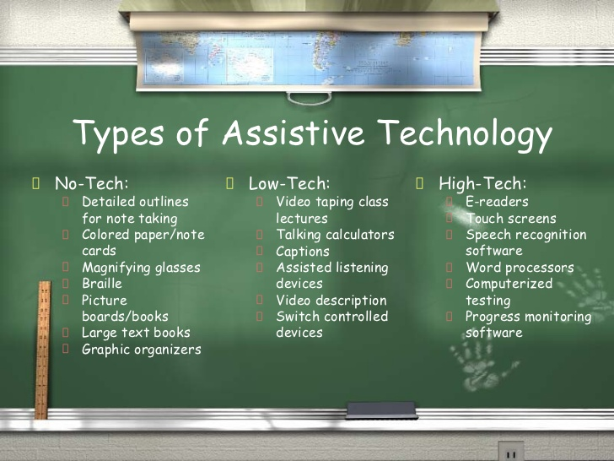
In today’s digital age, technology can be an extremely useful tool for educators. My dream is to have laptops or iPads for all students in my classroom. There are so many fantastic digital resources available for free on the internet that could greatly impact my student’s learning and positively influence their academic success. I know that this is not a possibility in every classroom and district, but I will apply for grants in hopes to achieve this goal. For my students with disabilities, assistive technology can be the one thing that breaks down the barrier to their academic success. Prior to the start of each school year, I will survey parents to find out if their student uses or requires any assistive technology devices. I will ensure that I understand the device and am comfortable using it to work and communicate with the students who need them. My job is to facilitate and guide student’s active construction of knowledge. I will use any means necessary to adapt and modify my lessons to ensure all students can fully participate and learn.
Building Community and Responding to Behavioral Challenges
Building a strong classroom community very early on is a crucial element for a successful school year. I will spend the first few weeks of the school year building that sense of community, practicing routines and procedures, and developing classroom rules with my students. We will read books and have discussions around topics like empathy, acceptance, and teamwork. We will begin each school day by having a morning meeting on the carpet where we talk about our goals for the day, how we can work together to accomplish them, and give shout-outs to other classmates. Rules for the classroom will be developed as a class so students feel that they play an important role in the classroom culture. I will have students practice routines and procedures early on so they become comfortable with them, and they become a norm for the rest of the year. “It pays to take a deliberate approach, to teach the details, the ins and outs, and the A to Z’s of being a polite, successful, and contributing member of your classroom” (Linsin, 2013). Throughout the year, I will have students work in different groups and partnerships so everyone feels comfortable working with each other and no one feels left out. We will continue to work together as a class on maintaining our classroom community throughout the year.
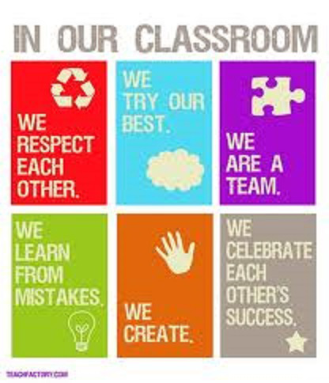
Behavior challenges will arise in every classroom regardless of the sense of community. Everyone has a bad day now and then. Classroom management skills are essential to be an effective teacher. I do not think it is appropriate to discipline a student in front of the others. Whenever it is possible, I will pull the student aside and address the issue in private. Students will be given 2 warnings to reflect on their behavior and make a change. If the behavior does not stop, I will have a “vacation station” where they will sit and fill out a behavior log entry. Once the log is filled out and the misbehavior does not stop, the student will fill out a “think sheet” that will be sent home to be signed by the parent. If necessary, I will reach out to parents or family member at home and have a conversation about the behavior. I believe redirecting and reminding language is helpful for most students to self-regulate their behavior. Most behavior challenges need to be addressed on an individual basis, based on what is happening, why it is happening, and what the student needs to change the behavior. I will work with parents to implement positive behavior support plans as needed.
Inclusive Instructional Strategies

Strategy 1: Elkonin Boxes
Define & explain: This strategy is used to help build students phonological awareness. When using Elkonin boxes, students learn to segment and blend sounds to create words. For this strategy, students listen to a word being said, repeat the word to themselves, and slide a small manipulative into a square as they hear each sound in the word. An example is shown here for the word dog.
After the teacher says the word dog, and they repeat it, the student would slide a place-marking manipulative into each box to represent the phonemes /d/, /o/, and /g/.
How I would use in an inclusive class: Phonological awareness is a key understanding students must have in order to learn to read. I would use this for all students to learn letter-sound relationships, but this skill is especially important for students with special needs. I could use this in a variety of ways, whole class, small group, partnered, or individually. In an inclusive classroom, I would have desks set up in groups of 4 to do this activity that way students can listen to their classmates and model both what I do, and what their classmates are doing.
How it benefits student with special needs:
- Moving the manipulatives to represent the sounds in each word adds a kinesthetic aspect to learning which has been shown to help students with special needs. This strategy aids students with learning disabilities transfer what they are hearing, to a tangible activity building phonological awareness.
- Research has shown that small group work is extremely beneficial to students with special needs in an inclusive classroom, especially those with cognitive impairments. I would have students practice this strategy in small groups.
- By adding a picture of the word, students with visual processing disorders are able to see how each word is broken into different phonemes or syllables.
- This strategy helps students with special needs because it incorporates visual, auditory, and kinesthetic ways to learn the segmenting and blending aspects of phonological awareness.
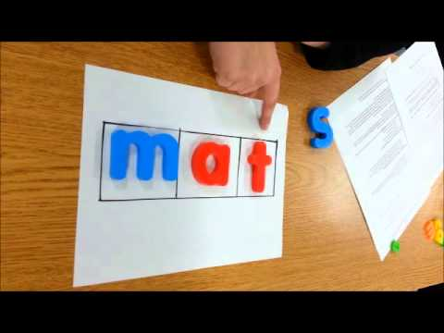
- This strategy also helps grow their understanding of the alphabetic principle.
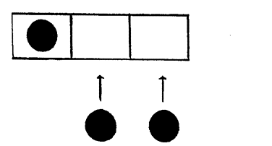

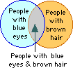
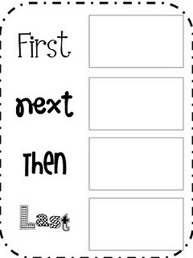
Strategy 2: Graphic Organizers
Define & explain: Graphic organizers are phenomenal ways for students to visually represent knowledge they are constructing in lessons. They can be used in virtually any content area, and there are an immeasurable number of adaptations teachers can make to fit the needs of the learner and the lesson. Like the name suggests, they are a means for students to organize information in a meaningful way that they can reference back to in order to remember a lot of information. They can be used to highlight specific facts, concepts, and/or ideas, as well as the relationships that logically hold them together. I have had much success using graphic organizers in my personal experiences working in a classroom.
How I would use in an inclusive class: Graphic organizers lend themselves nicely to both small group and partner work, as well as individual work. Modeling how to properly use them as a whole class discussion though, is important for students with special needs to fully understand their purpose and usage. In a lesson on comparing two things, a Venn diagram can be used to highlight similarities and differences. To help teach students sequencing, a diagram like the one shown here
can be useful so students can summarize each step of an event in a logical progression. The examples of ways to use graphic organizers are endless, and research has shown them to benefit all students, especially visual learners and those with special needs.
How it benefits student with special needs:
- Students with special needs often have a hard time organizing and arranging their thoughts and understandings in a meaningful way. This strategy will aid them in that regard.
- This strategy eases the process of synthesizing broad topics into more manageable chunks of information for a student with learning disabilities to process and remember.
- Using this strategy in small groups will help students with cognitive impairments, who have shown to perform better in small group work within an inclusive classroom.
- Most graphic organizers emphasize relationships, and that is something many students with special needs struggle with.
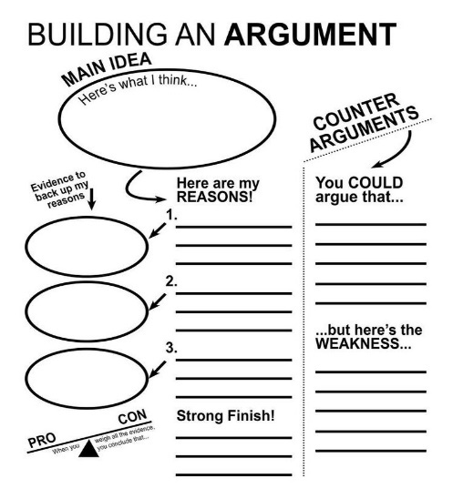
- Many students with special needs have difficulty making connections between thoughts, topics, and ideas. This strategy lends itself nicely to foster and grow those student’s connection making skills.
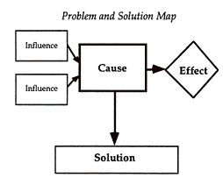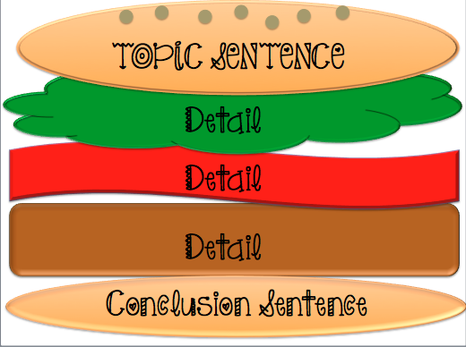

Strategy 3: Frayer Model
Define & explain:
The Frayer Model is a strategy that uses a graphic organizer for vocabulary building. This graphic organizer is a strategy that is divided into four components for recording information related to the concept. It requires students to:
- Define the target vocabulary words or concepts
- Apply this information by generating examples and non-examples.
How I would use in an inclusive class:
The Frayer Model promotes critical thinking and can be used to help students to identify and understand vocabulary. This model can be used with an entire inclusive classroom, small groups, or for individual work. This strategy can be used to make a word wall, which could be displayed in the classroom, or as an anchor chart. This is great for content area vocabulary learning.
How it benefits student with special needs:
- This strategy enhances vocabulary words in all of the content areas, which would benefit students who have deficits in reading fluency, vocabulary words, and blends.

- This strategy also provides illustrations, which could be used with students that have a visual perception deficit. The illustrations could assist them in being able to visually view the concept.

- This strategy can assist students with learning disabilities, which have difficulty organizing their thoughts and ideas.
(Dr. Marshall Reed, SED 5260 example for instructional strategy assignment)
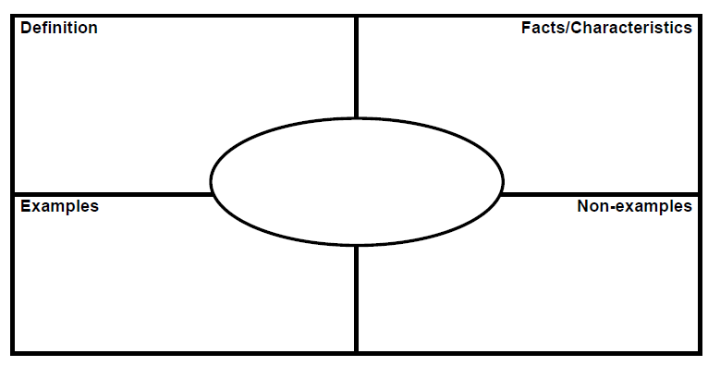

Strategy 4: Think-tac-toe
Define & explain: Think-tac-toe is a phenomenal tool to differentiate instruction and apply principles of Universal Design for Learning in student’s expression of knowledge. This method allows students to choose 3 or 4 options to show what they have learned. Using this strategy, multiple learning styles will be addressed and supported. This strategy can be easily adapted to fit any content area. This strategy is a great wrap-up activity at the end of a unit.
How I would use in an inclusive class: This strategy allows students to take ownership of their own learning and choose options that they want to complete to show and express that learning. Students pick the ones that they are able to complete successfully. This strategy can be used as an individual assignment or a group task. Students at higher ability levels may be given a different think-tac-toe board than students at lower ability levels.
How it benefits students with special needs:
- Addresses different learning styles, different levels of thinking, and Gardner’s multiple intelligences
- Sets students up for success because students can choose assignments they know they can complete successfully
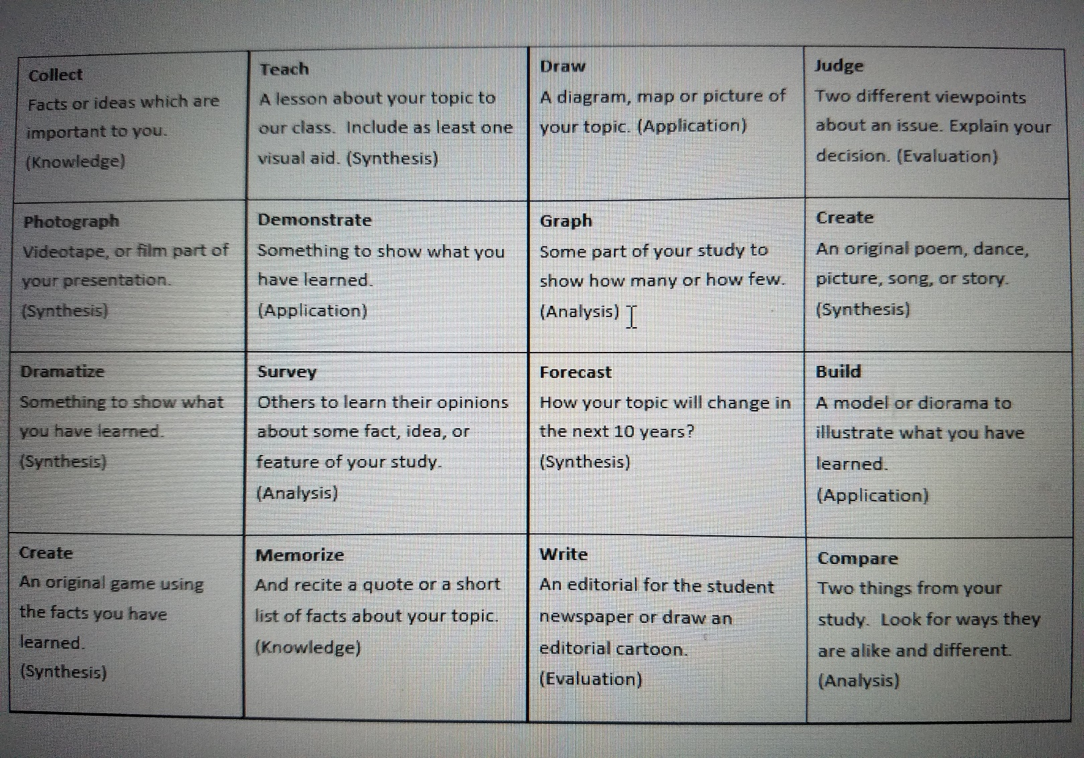
Lesson Plans
Wayne State University College of Education
Lesson Planning Framework for Effective Instructional Design
Teaching Intern(s): Maddison Babcock
Grade level of students for whom the lesson was developed: 2nd grade
Title of the lesson: Empathy
Time needed for lesson: 45 minutes
1. LEARNERS & LEARNING ENVIRONMENT
  - Engaging and Supporting Diverse Learners: Applying Principles of Universal Design for Learning
- this section will list out details about how the lessons engagement, representation, and expression will be adapted or adjusted to meet the varying needs of the students in the classroom.

  - Materials & Digital Tools Needed
- Sesame Street video- Mark Ruffalo Empathy
- Storybook or magazine page featuring strong emotion (emotional stimulus)
- poster paper and coloring utensils
2. OUTCOMES & ASSESSMENT
- State Standards and Student Outcomes—Learning Goals
- Standards
2. SL.1- Participate in collaborative conversations with diverse partners about grade 2 topics and texts with peers and adults in small and larger groups.
- Outcomes
- SWBAT define and understand empathy.
- SWBAT explain and use the five skills to develop empathy

- Assessment and Evaluation—Evidence of Student Learning
- Assessment
Students will be assessed on their participation in the lesson activity.
- Evaluation
Students will be evaluated on the poster they create at the end of the lesson.

3. INSTRUCTIONAL PRACTICE
- Introduction—Engaging Students, Activating Prior Knowledge, Setting Lesson Goals
- show the Sesame Street Mark Ruffalo video about Empathy
- write the word “empathy” on the board and ask, “Can anyone define empathy?”
- After discussion, write on the board the definition: “Empathy: the ability to understand and share the feelings of another person.”
- ask students to think of a time when someone showed you empathy, or when you showed someone else empathy.
- List up to ten responses on the board.
- Note which responses are similar

- Instructional Procedures—Engaging Students in Actively Constructing Deep Understanding
- On five cards, introduce the 5 Skills to Develop Empathy:
Step 1- Watch & Listen: What is the other person saying and what is their body language? Step 2- Remember: When did you feel the same way? Step 3- Imagine: Imagine how you might feel in that situation. Validate the wide range of emotions that come up. Step 4- Ask: Ask how the person is feeling. Step 5- Show You Care: Let them know that you care through your words and actions
- Show an emotional stimulus picture from a storybook or magazine (with an issue relevant to your students), and use the 5 Skills to analyze the picture and practice developing empathy:
• 1. What is happening? Ask, “How does the person feel?” “How can you tell?” Discuss strategies to figure it out, such as asking: “What do their words say? “What does their body language say?” “Does what they say match their body language?”
• 2. Have you felt the same way? Ask “When did something like this happen to you?”
• 3. Imagine how you might feel. Ask the class for examples of what it might feel like, and how they might act. Examples: “I’d feel like crying; I’d want to hit back; I’d feel very embarrassed.”
• 4. Find out how the person is feeling. Have students provide examples of what they could say to someone, such as “Are you OK? What happened to you? How do you feel? How are you doing?”
• 5. Ask the students how to show someone that you care, and list answers on the board. Some examples: “Listen with all your attention, spend time with them, stay with them (don’t leave), say, “I’m sorry you’re feeling this way.” Encourage them, “Let’s get help, how can I help? Do you need a hug? I’m here for you, etc.”

- Technology as a Tool for Effective Teaching & Learning
- project the Sesame Street video- Mark Ruffalo Empathy

- Closure—Students Summarizing and Synthesizing Their Learning
- students will create a poster that will be hung up outside the classroom. It will have what they think empathy means, how they can show empathy, and one goal they have to be more empathetic.

4. REFERENCES & RESOURCES
https://www.edutopia.org/pdfs/blogs/edutopia-taran-lesson7empathy.pdf
5. PROFESSIONAL RESPONSIBILITY: Teacher Reflection
To be completed after the lesson.

Wayne State University College of Education
Lesson Planning Framework for Effective Instructional Design
Teaching Intern(s): Maddison Babcock
Grade level of students for whom the lesson was developed: 3rd
Subject/content area(s) for the lesson: Math
Title of the lesson: Guided Math- Time
Time needed for lesson: roughly 15 minutes

1. LEARNERS & LEARNING ENVIRONMENT
a) Engaging and Supporting Diverse Learners: Applying Principles of Universal Design for Learning
- Students will sit in the following order, starting closest to me: E.Z, J, E.D, A, and P. EZ is very easily distracted, but proximity control works in most cases to keep him focused on the task at hand. J needs to have directions reread to him multiple times and talk through answers before he writes them as part of his IEP. By having him closer to me, I can have him whisper his thought process to me and not give answers to the other students. A and J cannot sit next to each other due to issues we have had in the past. J’s stimming becomes too distracting for A to focus. P and ED cannot sit by each other because of behavior issues in the past.
- Because I have noticed that these students are kinesthetic learners, I bought small clocks with moveable hands for each student so they are able to work on this lesson in a hands-on way. I believe this may help them stay on track more than just a verbal or written approach to this lesson.
- I will model using the small clocks before asking the students to use them, as well as thinking aloud how to complete one of the story problems before asking the students to do one themselves.
- After I read the story problems to the students, I will write them on the dry erase easel so they can hear and see the problem, as well as being able to refer back to it when answering the problem.
- We will begin by reviewing key concepts before we start the lesson because we have not worked on telling time in about a week.
b) Materials & Digital Tools Needed
- Small clock for each student
- Number line paper
- Pencil
- Dry erase easel
- Dry erase marker
- No digital tools necessary for this lesson
2. OUTCOMES & ASSESSMENT
a) State Standards and Student Outcomes—Learning Goals
· Standards
3. MD.1- Tell and write time to the nearest minute and measure time intervals in minutes. Solve word problems involving addition and subtraction of time intervals in minutes, e.g., by representing the problem on a number line diagram.
· Outcomes
My mentor teacher, partner teacher, and I have all noticed that this small group of students is still struggling with telling time. The main purpose of this lesson is to figure out where the disconnect is so we can further support these student’s learning needs with telling time. Based on the results of this lesson, more small group attention will be given to address their confusion.
- SWBAT verbally differentiate the purposes of the small hand and big hand of the analog clock.
- SWBAT illustrate the time on their small clock to represent the time given to them verbally.
- SWBAT demonstrate the addition and subtraction of time intervals using a number line.
b) Assessment and Evaluation—Evidence of Student Learning
· Assessment:
Students will be informally assessed, by teacher’s anecdotal notes, on whether or not they can distinguish between the purposes of the small and big hands on the clock; show the correct time on their small clocks; and correctly show the addition or subtraction of time intervals on the number line.
· Evaluation:
The purpose of this lesson is to gain a better understanding of where students confusion lies in regards to telling time and showing time intervals on a number line. The evaluation for this lesson will be to see what parts the students got wrong in order to determine what further supports each student needs to become comfortable telling time, and/or using a number line to represent time intervals. Points will be given for participation, using small group norms, and effort put into the activity. Students will also be self-evaluating themselves using thumb-o-meters.
3. INSTRUCTIONAL PRACTICE
a) Introduction—Engaging Students, Activating Prior Knowledge, Setting Lesson Goals
- “We have been recently talking about telling time, both in our math lessons as well as during calendar math every day.”
- “Telling time is something very important for our daily lives so it is important that we learn how to use clocks.”
- “Who will remind me what the small hand on the clock tells us?”
- call on a student for their answer, ask the other students to give the silent connection symbol if they agree. If they do not give the connection symbol, ask them why they do not agree and support as needed.
- “So if the small hand on the clock represents the hour…what does the big hand tell us?
- call on a student for their answer, ask the other students to give the silent connection symbol if they agree. If they do not give the connection symbol, ask them why they do not agree and support as needed.
b) Instructional Procedures—Engaging Students in Actively Constructing Deep Understanding
- “I am going to model for you how I would represent a certain time on one of these small clocks.”
- ask one or two of the students to give a time, think aloud the process of manipulating the hands on the clock to represent the time given
- pass out a small clock to each student
- “Now it’s your turn. I am going to give you a time and you will move the hands on your clock to show that time.”
- “Show me 3:00… 6:30… 8:15… 1:45… 10:22.”
- Give students time to move the hands for each time. When they are done, walk behind them and check the time they have shown. Take notes of students answers whether they are right or wrong.
- “Let’s think back to our math lesson where we used the number line to solve story problems about time. We are going to do some more of those now.”
- hand out timeline paper to each student.
- model and think aloud completing the first story problem (all story problems are listed at the end of this lesson).
- read the second story problem to the students and write it on the dry erase easel.
- give the students about a minute and a half to complete the problem on the number line.
- repeat the process for the next 2 story problems.
- collect students number line papers when they are finished.
c) Technology as a Tool for Effective Teaching & Learning
- No digital tools necessary for this lesson
d) Closure—Students Summarizing and Synthesizing Their Learning
- “Why is time important?”
- “Let’s do a couple thumb-o-meters for today’s small group. Remember to keep your thumbs at your heart.”
- “First we will do one for showing different times on the clock. Thumbs up if you are comfortable showing times on a clock. Thumbs in the middle if you think you need more practice. Thumbs down if you are lost and need more help.”
- “Now for using a number line to show time intervals. Thumbs up if you are comfortable using a number line to show the adding and subtracting of time. Thumbs in the middle if you need more practice. Thumbs down if you are confused and need more help.”
- “Thank you for showing tenacity to grapple through the struggles of today's small group.”
- Transition students back to their seats to work on math centers. Remind them that transitions are silent so we do not distract our friends hard work at their math center.
4. REFERENCES & RESOURCES
This lesson was created by myself, with the help and guidance of my mentor teacher Ms. Gross, the lead teacher in our 3rd grade classroom.
5. PROFESSIONAL RESPONSIBILITY: Teacher Reflection
To be completed after the lesson.

Wayne State University College of Education
Lesson Planning Framework for Effective Instructional Design
Teaching Intern(s): Maddison Babcock
Grade level of students for whom the lesson was developed: 2nd
Title of the lesson: ELA- The Everybody Club (sequencing events)
Time needed for lesson: 60 minutes
1. LEARNERS & LEARNING ENVIRONMENT

- Engaging and Supporting Diverse Learners: Applying Principles of Universal Design for Learning
- this section will list out details about how the lessons engagement, representation, and expression will be adapted or adjusted to meet the varying needs of the students in the classroom.
- Materials & Digital Tools Needed
- "The Everybody Club" by Anne O’Brien
- copies fop "The Everybody Club"
- construction paper, yarn, and coloring utensils for the mobile.

2. OUTCOMES & ASSESSMENT

- State Standards and Student Outcomes—Learning Goals
- Standards
2. RL. 5- Describe the overall structure of a story, including describing how the beginning introduces the story and the ending concludes the action.
2. SL.2- Recount or describe key ideas or details from a text read aloud or information presented orally or through other media.
- Outcomes
SWBAT identify the sequence of events of "The Everybody Club".
SWBAT separate the story into different events and illustrate and describe the event in a story mobile.
- Assessment and Evaluation—Evidence of Student Learning
- Assessment
Students will be informally assessed throughout the lesson, using a checklist, about whether outcomes and standards are being understood
- Evaluation
Students will be evaluated on their story mobiles

3. INSTRUCTIONAL PRACTICE

- Introduction—Engaging Students, Activating Prior Knowledge, Setting Lesson Goals
- review story elements with students (character, setting, plot, and solution)
- introduce the story- ask students to offer predictions of the story.
- introduce that stories are comprised of different events.
- Instructional Procedures—Engaging Students in Actively Constructing Deep Understanding
- Read aloud "The Everybody Club".
- While reading, "think aloud" the different things that are occurring.
- After the read aloud, "think aloud" a summary of the events that happened.
- As a class, review the key events that happened.
- Write the student’s ideas on the board.
- On a graphic organizer, students will complete the sequence of events.
- Technology as a Tool for Effective Teaching & Learning
- no technology is used in this lesson
- Closure—Students Summarizing and Synthesizing Their Learning
- students will create a story mobile using the construction paper, yarn, and coloring
- students will be grouped to match ability levels, and each group will be given a book to sequence. The lowest ability group will create a story mobile with The Everybody Club.
- each student will have their own color of construction paper to ensure each student contributes to the mobile
- give students time to work on mobiles
- once all groups are finished, have each group share their mobiles with the rest of the class
- hang up each groups mobile somewhere in the classroom

4. REFERENCES & RESOURCES
http://www.teachnology.com/lessons/lsn_pln_view_lessons.php?action=view&cat_id=9&lsn_id=13515
5. PROFESSIONAL RESPONSIBILITY: Teacher Reflection
To be completed after the lesson.
Support and Collaboration
The old adage “it takes a village to raise a child” comes to mind when I think of collaboration in the school environment. The support staff in the school and available resources in the community are essential when working with students with special needs. These people may include the reading specialist, speech language pathologist, social worker, media/technology specialist, among many other possibilities. In an inclusive classroom, the biggest asset I will have is the special education teacher in the building. I will work closely with him/her to ensure we are on the same page with students IEP goals and objectives. I can also ask for their thoughts and ideas about how I can make sure those are met. Each collaboration will exist for the benefit of my students, and to meet their needs. I will individually assess what my students need, and create and maintain the relationships with support personnel to make sure I am adequately prepared to make sure each student has the tools they need to succeed.
“In our increasingly interdependent and specialized world, it is unlikely that any one person has enough knowledge and ability in any field of endeavor to handle every circumstance. So it is reasonable and prudent to consult, collaborate, and team up in partnerships with others to achieve common goals” (Dettmer, Knackendoffel & Thurston, 2013). I will work with a team of personnel with expertise on the student and their needs, and use the collaboration consultation model to address issues that arise with students in the classroom. This model follows these steps: gathering data and establishing goals, identifying specific problems, recommending possible interventions, implementation, evaluations, and following up on progress made. I am committed to collaborating with any person necessary to ensure ALL students have a fair chance at academic success.

Strategies for Change
If I want to make a move toward a more inclusive school, I must first be a model for how effective inclusion looks like. I will be an open book for my coworkers, sharing resources and knowledge I have of what effective inclusion looks like. I will explain the benefits, to all parties, that inclusive schools and classrooms offer. I will plan and host meetings with coworkers to assess the inclusiveness of our school, set goals, and make steps toward achieving them. I will work with the administration of my school or district to have professional development meetings about inclusion and collaboration. Small steps must be made first to work towards inclusion, but every step matters because it benefits the students involved.

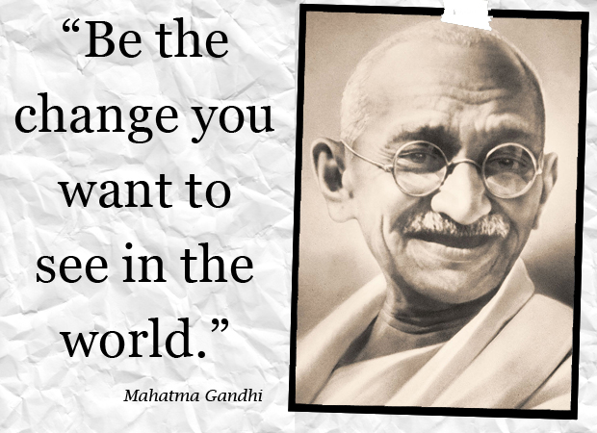
References

Dettmer, P., Knackendoffel, A., & Thurston, L. P. (2013). Collaboration, consultation, and
teamwork for students with special needs (7th ed.). Boston: Pearson.
Linsin, M. (2013, August 24). Why You Should Take Your Time the First Few Weeks of
School. Retrieved from https://www.smartclassroommanagement.com/2013/08/24/why-you-should-take-your-time-the-first-weeks-of-school/

